**Caseificio sapori di montegnago**

All our products are made with raw milk: we do not heat up the milk before producing cheese because there is growing evidence that these kinds of cheese are the finest ones. The higher bacterial charge of animals coming from one single cow stall bring more flavor, fragrance and quality.

Moreover, keeping lactic ferments alive permits to preserve typical and territorial characteristics of the milk, because it does not undergo significant changes in temperature. This is due to the proximity between the stable cow and the boiler.

In order to respect the traditional production methods, we use the classical copper boiler, which is fundamental not only for technological reason ( heat transfer, non-adhesion of milk to the side of the boiler, cooking time decrease), but also for biological reason: copper influences the acidification, the maturation and the biochemical reactions during the cheese making

For all reason, we will always be available to let you visit the farm, which is located in the same place of the diary shop , and you will have the chance to see the cheese- making stages.

**Caseificio sapori di montegnago **

All our products are made with raw milk: we do not heat up the milk before producing cheese because there is growing evidence that these kinds of cheese are the finest ones. The higher bacterial charge of animals coming from one single cow stall bring more flavor, fragrance and quality.

Moreover, keeping lactic ferments alive permits to preserve typical and territorial characteristics of the milk, because it does not undergo significant changes in temperature. This is due to the proximity between the stable cow and the boiler.

In order to respect the traditional production methods, we use the classical copper boiler, which is fundamental not only for technological reason ( heat transfer, non-adhesion of milk to the side of the boiler, cooking time decrease), but also for biological reason: copper influences the acidification, the maturation and the biochemical reactions during the cheese making

For all reason, we will always be available to let you visit the farm, which is located in the same place of the diary shop , and you will have the chance to see the cheese- making stages.

Our products

Mozzarella

Ricotta

Treccia di mozzarella

Caciotta with red chicory

Fresch caciotta

Tosella

Stracchino

Crò ( Semi-aged Asiago)

Formagella

Topolino (Blue cheese)

Bloomy rind cremini

******Yoghurt

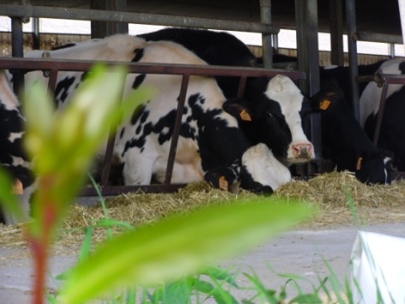

Caciotta with chives

Caciotta whit olives

Cacotta whit pepper

Aged Caciotta

Murlone (taleggio)

Spineo (fresh Asiago)

Cengia (Aged Asiago)

Robiola

Truffle cheese

Montegnago( aged spicy cheese)

Panna Cotta

**Opening Times**

**From Tuesday to Saturday**

**From 3.00 PM to 7.00 PM**

**Closed on Monday**

[saporidimontegnago@gmail.com](mailto:saporidimontegnago@gmail.com)

**Via A. Palladio 1**

**36021 Villaga Loc.Belvedere (VI)**

**Negozio 0444 891374**

**Cell 3404605755**

**Our Products**

Caciotta with chives

Caciotta whit olives

Cacotta whit pepper

Aged Caciotta

Murlone (taleggio)

Spineo (fresh Asiago)

Cengia (Aged Asiago)

Robiola

Truffle cheese

******Montegnago( aged spicy cheese)

Panna Cotta



Ricotta

Treccia di mozzarella

Caciotta with red chicory

Fresch caciotta

Tosella

Stracchino

Crò ( Semi-aged Asiago)

Formagella

Topolino (Blue cheese)

Bloomy rind cremini

Yoghurt

**Opening Times**

**From Tuesday to Saturday**

**From 3.00 PM to 7.00 PM**

**Closed on Monday**

[saporidimontegnago@gmail.com](mailto:saporidimontegnago@gmail.com)

**Via A. Palladio 1**

**36021 Villaga Loc.Belvedere (VI)**

**Negozio 0444 89137**

**Cell 3404605755**